CRITICAL AND CREATIVE THINKING TEST ITEMS

CLASS VIII SUB: SCIENCE CHAPTER- 16 : LIGHT

INDEX

S.NO. | TEST ITEM | Page no.
1 | Reflection of light
2 | Dispersion of light
3 | Persistence of Vision
4 | Reflection of Light
5 | Reflection of light
6 | Dispersion of Light
7 | Reflection of light
8 | Eye donation
9 | Defects of vision
10 | Scattering of light
11 | Answers (to 8,9 & 10)
12 | Braille script
13 | Understanding Kaleidoscope

TEST ITEM -1
Reflection of light
Domain: Scientific Literacy | Theme: Reflection of light | Class(es): VIII,IX,X  Expected Time:10 mins  Total Credit-8marks
Description of Item  Sameer, a student of class VIII went for watching a movie in a cinema hall. There he observed the screen of the hall is white in colour and is rough enough.  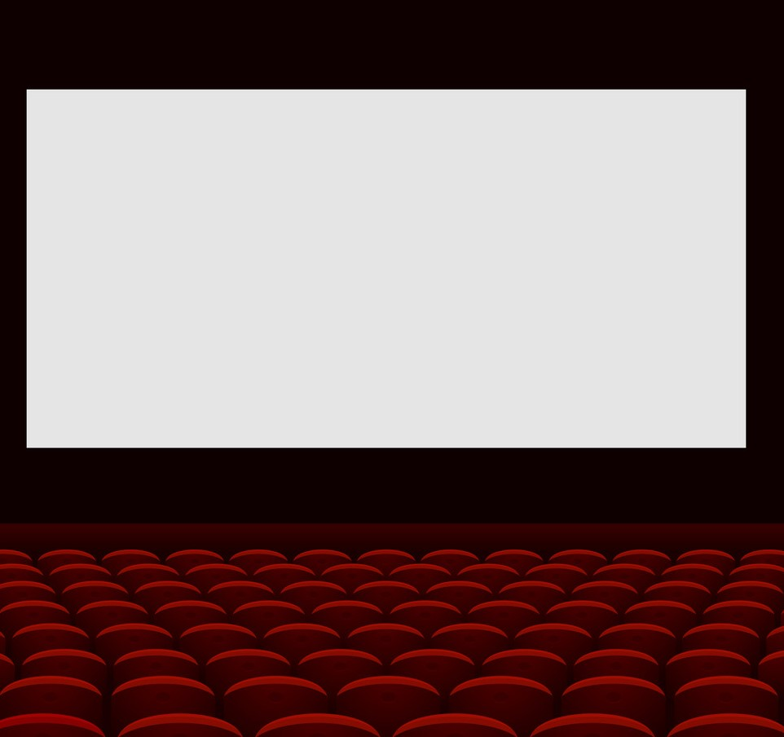 | Learning outcomes:  Explain the phenomena scientifically

Q.1.Do you think that making the screen rough helps in seeing the images clearly? Give reason.
Ans……………………………………………………………………………………………………………………………………………………………………………………………………………………………………………………………………………………………………………………………….

FRAMEWORK | CHARACTERISTICS
Competency | Explain phenomena scientifically
Knowledge System | Content knowledge
Context | Global
Cognitive Demand | Medium
Item format | Short response items
Proficiency Level | 3 to 4

Q.2.Do you think that the laws of Reflection is valid for diffused reflection also?-Give reason.
Ans……………………………………………………………………………………………………………………………………………………………………………………………………………………………………………………………………………………………………………………

FRAMEWORK | CHARACTERISTICS
Competency | Designing Scientific Enquiry
Knowledge System | Content knowledge
Context | Global
Cognitive Demand | Medium
Item format | Short response items
Proficiency Level | 4

Q.3.If two mirrors are kept at right angle with each other, how many images will be formed?
Ans……………………………………………………………………………………………………………………………………………………………………………………………………………………………………………………………………………………………………………………

FRAMEWORK | CHARACTERISTICS
Competency | Explain phenomena scientifically
Knowledge System | Content knowledge
Context | Global
Cognitive Demand | Medium
Item format | Short response items
Proficiency Level | 2

Q.4.After sunset, for sometimes there exists some light. Where from we get this light?
Ans:……………………………………………………………………………………………………………………………………………………………………………………………………………………………………………………………………………………………………………………………..

FRAMEWORK | CHARACTERISTICS
Competency | Explain phenomena scientifically
Knowledge System | Content knowledge
Context | Global
Cognitive Demand | Medium
Item format | Closed Constructed
Proficiency Level | 4

Scientific literacy
Credit pattern:
Full Credit:02
Partial Credit:01
Nil Credit:00

Description of Answer Key and Credits:
Ans.1: Yes, rough screen helps in diffused reflection of light.-Full Credit, Other response-No Credit

Ans.2: Yes, at every point of incidence both the laws are valid. Rays lie on same plane and i=r is also
valid- Full Credit, Other response-No Credit.

Ans.3: 3 images-Full Credit, Other response-No Credit

Ans.4: Diffused reflection from the dust particles-Full Credit, Other response-No Credit

Name of the Teacher/Item Writer: RATUL BISWAS
Designation: PGT(PHYSICS)
Email: ratulbiswas1990@gmail.com
Phone No.: 8902705303
Name of the Vidyalaya: KENDRIYA VIDYALAYA CHAKRADHARPUR
KVS Region: RANCHI

TEST ITEM -2
Dispersion of light

Domain: Scientific Literacy | Theme: Dispersion of light | Class(es):VIII,IX,X  Expected Time:10 mins  Total Credit-8
Description of Item  Sometimes after the rain in clear sky Rainbow appears. Where we get to see seven colours in the form of a bow.   | Learning outcomes:  Students will be able to  explain the phenomena scientifically

Q.1.What is the name of the phenomena because of which white light gets separated into 7 colours?
Ans…………………………………………………………………………………………………………………………………………………………………………………………………………………………………………………………………………………………………………………………

FRAMEWORK | CHARACTERISTICS
Competency | Explain phenomena scientifically
Knowledge System | Content knowledge
Context | Global
Cognitive Demand | Medium
Item format | Short response items
Proficiency Level | 2

Q.2.Why rain is an important factor in the formation of Rainbow?
Ans……………………………………………………………………………………………………………………………………………………………………………………………………………………………………………………………………………………………………………………………….
FRAMEWORK | CHARACTERISTICS
Competency | Designing Scientific Enquiry
Knowledge System | Content knowledge
Context | Global
Cognitive Demand | High
Item format | Short response items
Proficiency Level | 4

Q.3.If a white light passes through a rectangular glass slab, will the white light get separated into different colours?
Ans………………………………………………………………………………………………………………………………………………………………………………………………………………………………………………………………………………………………………………………………
FRAMEWORK | CHARACTERISTICS
Competency | Explain phenomena scientifically
Knowledge System | Content knowledge
Context | Global
Cognitive Demand | Medium
Item format | Short response items
Proficiency Level | 4

Q.4.If the white is replaced by a yellow light, will you observe the separation?
Ans:……………………………………………………………………………………………………………………………………………………………………………………………………………………………………………………………………………………………………………………………..

FRAMEWORK | CHARACTERISTICS
Competency | Explain phenomena scientifically
Knowledge System | Content knowledge
Context | Global
Cognitive Demand | Medium
Item format | Closed Constructed
Proficiency Level | 3

Scientific literacy
Credit pattern:
Full Credit:02
Partial Credit:01
Nil Credit:00

Description of Answer Key and Credits:
Ans.1: Dispersion of light-Full Credit, Other response-No Credit

Ans.2: Rain water droplets act as dispersing medium-Full Credit, Other response-No Credit.

Ans.3: No, as two refracting surfaces should be non-parallel-Full Credit, Other response-No Credit

Ans.4: No.-Full Credit, Other response-No Credit

Name of the Teacher/Item Writer: RATUL BISWAS
Designation: PGT(PHYSICS)
Email: ratulbiswas1990@gmail.com
Phone No.: 8902705303
Name of the Vidyalaya: KENDRIYA VIDYALAYA CHAKRADHARPUR
KVS Region: RANCHI
TEST ITEM -3
Persistence of Vision
Domain: Scientific Literacy | Theme: Persistence of Vision | Class(es):VIII,IX,X  Expected Time:10 mins  Total Credit-8marks
Description of Item  When we enter any darkened room from bright sunshine, we failed to see the surroundings clearly. But after sometimes, the things normalize and vision gets improve. | Learning outcomes: Students will be able to Explain the phenomena scientifically

Q.1.What do you think, what is the reason behind the problem mentioned above?
Ans…………………………………………………………………………………………………………………………………………………………………………………………………………………………………………………………………………………………………………………………

FRAMEWORK | CHARACTERISTICS
Competency | Explain phenomena scientifically
Knowledge System | Content knowledge
Context | Global
Cognitive Demand | Medium
Item format | Short response items
Proficiency Level | 2

Q.2.If we see any bright object and close our eyes, the image remains in our eyes for a very short duration of time. Which phenomena is responsible for it?
Ans………………………………………………………………………………………………………………………………………………………………………………………………………………………………………………………………………………………………………………………………………………………………………………………………………………………………………………………………………………………………………………………………………………………………………………………………………………………………………………………………………..
FRAMEWORK | CHARACTERISTICS
Competency | Designing Scientific Enquiry
Knowledge System | Content knowledge
Context | Global
Cognitive Demand | Medium
Item format | Short response items
Proficiency Level | 2

Q.3.Movies are actually still pictures.
Ans. True/False.

FRAMEWORK | CHARACTERISTICS
Competency | Explain phenomena scientifically
Knowledge System | Content knowledge
Context | Global
Cognitive Demand | Medium
Item format | True False Based
Proficiency Level | 2

Q.4.The images at the Retina of our eyes remains for approximately seconds.
Ans. True/False

FRAMEWORK | CHARACTERISTICS
Competency | Explain phenomena scientifically
Knowledge System | Content knowledge
Context | Global
Cognitive Demand | Medium
Item format | True False based
Proficiency Level | 2

Scientific literacy
Credit pattern:
Full Credit: 02
Partial Credit: 01
Nil Credit: 00

Description of Answer Key and Credits:
Ans.1: Light does not enter to eyes as size of the pupil remains small and after sometimes it neutralizes-Full Credit, Other response-No Credit

Ans.2: Persistence of Vision-Full Credit, Other response-No Credit.

Ans.3: True-Full Credit, Other response-No Credit

Ans.4: True-Full Credit, Other response-No Credit

Name of the Teacher/Item Writer: RATUL BISWAS
Designation: PGT(PHYSICS)
Email: ratulbiswas1990@gmail.com
Phone No.: 8902705303
Name of the Vidyalaya: KENDRIYA VIDYALAYA CHAKRADHARPUR
KVS Region: RANCHI
TEST ITEM -4
Reflection of Light

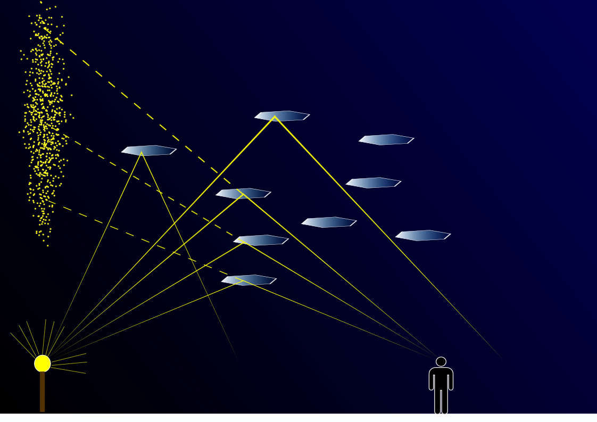
Domain : Scientific Literacy | Theme: Reflection of Light | Class: VIII  Expected time: 5 Min.  Total credit: 4
Description of items: | Learning outcome: Knowledge, Observation and analyzing
  Text | Text
  Image | Image
   | Table
   | Graph
   | Map
Since they are caused by the interaction of light with ice crystals, light pillars belong to the family of halos. The crystals responsible for light pillars usually consist of flat, hexagonal plates, which tend to orient themselves more or less horizontally as they fall through the air. Each flake acts as a tiny mirror which reflects light sources which are appropriately positioned below it (See drawing), and the presence of flakes at a spread of altitudes causes the reflection to be elongated vertically into a column. The larger and more numerous the crystals, the more pronounced this effect becomes. (More rarely, column-shaped crystals can cause light pillars as well. In very cold weather, the ice crystals can be suspended near the ground, in which case they are referred to as diamond dust.

Unlike a light beam, a light pillar is not physically located above or below the light source. Its appearance as a vertical line is an optical illusion, resulting from the collective reflection off the ice crystals; but only those that are in the common vertical plane, direct the light rays towards the observer (See drawing). This is similar to the reflection of a light source in a body of water, but in this case there are a million lakes adding to the effect.

Q.1. A light pillar is an optical illusion. It is a virtual image. Can a Virtual image be photographed? Explain.

Scientific Literacy
FRAMEWORK | CHRACTERISTICS
Competency | Explaining phenomenon Scientifically
Knowledge-system | Content based
Context | Global
Cognitive demand | Medium
Item format | Constructed response
Proficiency Level | 2

Type:- Application, closed ended.
Full credit:- 2, for correct and explanation
Partial credit:- 1, for correct answer or explanation
Nil credit:- 0, for wrong

Q.2. Will this light pillar is similarly visible, if observer changes its position? If not, then why?
Scientific Literacy

FRAMEWORK | CHRACTERISTICS
Competency | Explaining phenomenon Scientifically
Knowledge-system | Application
Context | Global
Cognitive demand | Medium
Item format | Open constructional approach
Proficiency Level | 2

Type:- Analysis, open ended
Full credit:- 2, for correct, and explanation
Partial credit:- 1, for correct answer or explanation
Nil credit:- 0, for wrong
Description of Answer Key and Credits:

Q.1. Yes, can be photographed. Virtual and erect object image is real and inverted.

Q.2. No. With the change in position, angle of incidence changes and hence angle of reflection. Thus, shape and size changes.

Name of the Teacher: Jayant Kumar Sinha
Designation: PGT (Physics)
Email: jksinharanchi@gmail.com
Phone No: 9430731515
Name of the Vidyalaya : K V CRPF, Ranchi
KVS Region: Ranchi

TEST ITEM -5
Reflection of light

Domain : Scientific Literacy | Theme: Reflection of light | Class: VIII  Expected time: 4 Min.  Total credit: 3
Description of items: | Learning outcome: Knowledge, Observation and analyzing
  Text | Text
  Image | Image
   | Table
   | Graph
   | Map
Light is scattered off all points of the pencil and into all directions of space. If light directed toward the mirror is reflected into your eye, you see the image of the pencil. (a) As part (a) of the figure shows, if the top half of the mirror is covered, light scattered from the pencil and reflected off the mirror can enter your eye and you will see the image of the pencil. (b) As part (b) of the figure shows, if the bottom half of the mirror is covered, light scattered from the pencil cannot be reflected off the mirror in such a matter that it enters your eye. You cannot see the image of the pencil.
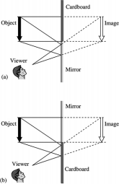

Q.1. If whole mirror is exposed, then what will be difference in the image, as compared to half covered?

Scientific Literacy
FRAMEWORK | CHRACTERISTICS
Competency | To retrieve information
Knowledge-system | Content based
Context | Local
Cognitive demand | Medium
Item format | Closed constructed
Proficiency Level | 3

Credit Pattern:
Full Credit: 2, same size, higher intensity
Partial Credit: 1, only same size or higher intensity
Nil Credit: 0
Q.2. what should be minimum size of a mirror to get a full size of a body of 1.5 meter?
Scientific Literacy
FRAMEWORK | CHRACTERISTICS
Competency | To retrieve information
Knowledge-system | Procedural
Context | Local
Cognitive demand | Medium
Item format | Closed constructed
Proficiency Level | 2
Credit Pattern:
Full Credit: 1, for correct answer
Nil Credit: 0, for incorrect answer

Description of Answer Key and Credits:
Q.1. Same size but of higher intensity.
Q.2. 1.5/2 = 0.75 meter

Name of the Teacher: Jayant Kumar Sinha
Designation: PGT (Physics)
Email: jksinharanchi@gmail.com
Phone No: 9430731515
Name of the Vidyalaya : K V CRPF, Ranchi
KVS Region: Ranchi

TEST ITEM -6
Dispersion of Light

Domain : Scientific Literacy | Theme: Dispersion of Light | Class: VIII  Expected time: 10 min.  Total credit: 5
Description of items: | Learning outcome: Students will be able to apply knowledge of dispersion of light in their daily life
  Text | Text
  Image | Image
   | Table
   | Graph
   | Map

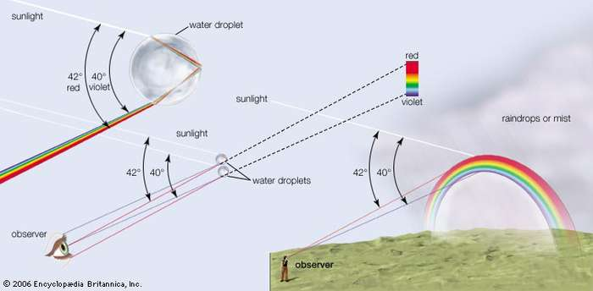
A rainbow is formed when it rains and there’s sunshine simultaneously. Each raindrop is made of a different shape and has a different consistency as compared to a glass prism, still it affects light in a similar fashion. One can see the seven constituent colors (red, orange, yellow, green, blue, indigo and violet) when white light (sunlight) hits a collection of raindrops at a fairly low angle.
When the white sunlight travels from air into the drop of water, the constituent colors of light slow down to varying speed and frequencies. When violet light enters the raindrop, it bends at a relatively sharp angle. Some of the light then passes back out into the air, and the rest is reflected back. Some of that reflected light passes out of the drop, bending as it moves back into the air again.
This way, each raindrop disperses the white sunlight into its constituent colors. We see a wide band of colour, as if different rainy areas were dispersing a different single colour since we only see one colour from each raindrop.
Sometimes we also see a double rainbow, a sharp rainbow with a fainter rainbow above it. The fainter rainbow occurs in the same manner as the sharper rainbow, but here the light is reflected twice inside the raindrop instead of reflecting once. Due to this double reflection, the light exits the raindrop at a different angle, so we see it above the sharper rainbow. And if you observe carefully, you’ll notice that the colors in the secondary rainbow are in the reverse order of the primary rainbow.

Q.1. Rainbow is formed due to which of the following?
a. By dispersion of sunlight
b. By scattering of sunlight
c. By reflection of sunlight
d. None of the above
Scientific Literacy
FRAMEWORK | CHRACTERISTICS
Competency | Explaining phenomenon scientifically
Knowledge-system | Content based
Context | Global
Cognitive demand | Medium
Item format | MCQ
Proficiency Level | 2
Credit Pattern:
Full Credit: 1, for correct
Partial Credit: 0
Nil Credit: 0 , for incorrect
Q.2. For the blue color of the sky, what characteristic property of light is responsible?

Scientific Literacy
FRAMEWORK | CHRACTERISTICS
Competency | To retrieve information
Knowledge-system | Procedural
Context | Global
Cognitive demand | Medium
Item format | Closed constructed
Proficiency Level | 1
Credit Pattern:
Full Credit: 1, for correct
Nil Credit: 0, for incorrect

Q.3.What is the order of colours of light in primary and secondary rain bow?
Scientific Literacy
FRAMEWORK | CHRACTERISTICS
Competency | To retrieve information
Knowledge-system | Procedural
Context | Global
Cognitive demand | Medium
Item format | Closed constructed
Proficiency Level | 3
Credit Pattern:
Full Credit: 2, for both correct
Partial Credit: 1, for single correct
Nil Credit: 0, for both incorrect

Q.4. In which direction a rainbow is normally observed?
(a) East, West
(b) West, North
(c) North, South
(d) South, West
Scientific Literacy

FRAMEWORK | CHRACTERISTICS
Competency | Analyzing Phenomenon
Knowledge-system | Procedural
Context | Global
Cognitive demand | Medium
Item format | MCQ
Proficiency Level | 2

Credit Pattern:
Full Credit: 1, for correct
Nil Credit: 0, for incorrect
Description of Answer Key and Credits:
Q.1. a) dispersion of light
Q.2. Scattering
Q.3. Primary :-VIBGYOR, Secondary :- ROYGBIV
Q.4. a) East- West

Name of the Teacher: Jayant Kumar Sinha
Designation: PGT (Physics)
Email: jksinharanchi@gmail.com
Phone No: 9430731515
Name of the Vidyalaya : K V CRPF, Ranchi
KVS Region: Ranchi

TEST ITEM -7
Reflection of light

Domain : Scientific Literacy | Theme: Reflection of light | Class: VIII  Expected time: 4 min.  Total credit: 6
Description of items: | Learning outcome: Students will be able to apply phenomena of reflection of light
  Text | Text
  Image | Image
   | Table
   | Graph
   | Map

When a light ray strikes a surface separating two media with different optical properties, part of the light energy is reflected back to the media where it coming from. When light strikes a perfectly reflecting surface, such a mirror for example, all the light energy is reflected.
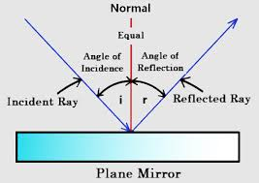
The surface separating the two media is called the interface or boundary.
The point at which the incident ray strikes the interface is called the point of incidence.
i is the angle made by the incident ray and the normal to the interface and is called the angle of incidence.
r is the angle made by the reflected ray and the normal to the interface and is called the angle of reflection.
Laws of reflection
(1) The incident light ray, the reflected light ray and the normal to the interface at the point of incidence make a plane called the plane of incidence
(2) The angle of incidence and the angle of reflection have the same size.
----------------------------------------------------------------------------------------------------------------------------------------
Q.1. A light ray strikes a reflective plane surface at an angle of 56° with the surface.
a) Find the angle of incidence.
b) Find the angle of reflection.
c) Find the angle made by the reflected ray and the surface.
d) Find the angle made by the incident and reflected rays.
Scientific Literacy
FRAMEWORK | CHRACTERISTICS
Competency | Interlink of Science
Knowledge-system | Content based
Context | Local
Cognitive demand | Medium
Item format | Closed constructed
Proficiency Level | 2
Credit Pattern:
Full Credit: 4, for all correct
Partial Credit: 1, for each correct
Nil Credit: 0, for all incorrect

Q.2. A ray of light is reflected by two parallel mirrors (1) and (2) at points A and B. The ray makes an angle of 25° with the axis of the two mirrors.
B
25⁰

A

a) What is the angle of reflection at the point of incidence A?
b) What is the angle of reflection at the point of incidence B?
Scientific Literacy
FRAMEWORK | CHRACTERISTICS
Competency | Interlink of Science
Knowledge-system | Content based
Context | Local
Cognitive demand | High
Item format | Closed constructed
Proficiency Level | 3

Credit Pattern:
Full Credit: 2, for both correct
Partial Credit: 1, for one correct
Nil Credit: 0, no correct
Description of Answer Key and Credits:
Q.1. a) 90⁰ -56⁰= 34⁰
b) I = r, 34⁰
c) 56⁰
d) 68⁰
Q.2. a) 65⁰
b) 65⁰

Name of the Teacher: Jayant Kumar Sinha
Designation: PGT (Physics)
Email: jksinharanchi@gmail.com
Phone No: 9430731515
Name of the Vidyalaya : K V CRPF, Ranchi
KVS Region: Ranchi

Domain: Scientific Literacy | Theme: Eye donation | Classes: VIII,IX,X  Expected Time:25 Minutes  Total Credit - 8
Description of Item | Learning outcomes: To know the importance of eye donation.
TEST ITEM -8
Eye donation
EYE DONATION

Zack and Sherah, donor and donor mom
Sherah was living in Guyana, a country on South America’s North Atlantic coast, when she gave birth to Zack. Complications during labour and delivery caused Zack to have cerebral palsy, which left him unable to communicate verbally and with severe breathing issues. Seeking better medical treatment, Sherah and Zack moved to New York City when he was three. Despite the improved conditions, Zack passed away at age nine due to complications associated with his disorder. Sherah was asked if she wanted Zack to be a donor. She had never thought about donation, but consented anyway in the midst of her grief. Zack was a smiley child who loved life and people, but his physical limitations left Sherah feeling unsure of how he would be able to contribute. She knows now that Zack was able to make a big impact through eye and tissue donation.
1.1 What is the correct time for the donation of eyes after death?
Tick the correct answer
- Any time after death
- Eye donation must be within 4 – 6 hours after death.
- Before crimination.
- After 24 hours of death

FRAMEWORK | CHARACTERISTICS
Competency | Explain phenomena scientifically
Knowledge System | Content knowledge
Context | Global
Cognitive Demand | low
Item format | Short response items
Proficiency Level | 1 to 2

1.2. How much do you agree with the following statement?

Tick mark the correct option | Yes | No
- During eye donation whole eye ball is taken out.
- A person’s blood group does not hamper his or her eye donation.
- A person suffering from communicable diseases can donate eye.

FRAMEWORK | CHARACTERISTICS
Competency | Explain phenomena scientifically
Knowledge System | Content knowledge
Context | Global
Cognitive Demand | Low
Item format | Fact
Proficiency Level | 2

1.3. Which part of the damaged eye can restore through eye donation?
A. Retina of the eye
B. Lens of the eye
C. Cornea of the eye
D. Iris of the eye

FRAMEWORK | CHARACTERISTICS
Competency | Explain phenomena scientifically
Knowledge System | Content knowledge
Context | Global
Cognitive Demand | Medium
Item format | Open constructed response items
Proficiency Level | 2

1.4. Is eye donation a noble act? Justify your answer.

FRAMEWORK | CHARACTERISTICS
Competency | Explain phenomena scientifically
Knowledge System | Content knowledge
Context | Global
Cognitive Demand | Medium
Item format | Closed constructed response items
Proficiency Level | 2

TEST ITEM -9
Defects of vision

Domain: Scientific Literacy | Theme: Defects of vision | Classes: VIII,IX,X  Expected Time:20 Minutes  Total Credit - 6
Description of Item | Learning outcomes: To know how defects of vision occur in human being.

Defects of vision
Sometime the eye may gradually lose its power of accommodation. In such condition the person cannot see the objects clearly and comfortable. He feels strains in the eyes. The vision becomes blurred due to the refractive defects of the eye. Arun was 14 years old. He was studying in class 8, he was a backbencher. He always complained about having a headache while reading in the classroom. One day teacher asked him to read line written on the blackboard, he could not read the line. Teacher suggested him to consult an eye specialist. After 3 days, he came back to school wearing a spectacle.

Source: Class X reference book.

2.1. Why was Arun not able to read the line on the blackboard? Tick the correct answer.
- The word written on the blackboard was too small to read.
- The line written on the blackboard was meaningless.
- He was having an eye defect called myopia

FRAMEWORK | CHARACTERISTICS
Competency | Explain phenomena scientifically
Knowledge System | Content knowledge
Context | Global
Cognitive Demand | Medium
Item format | Simple MCQ
Proficiency Level | 2

2.2. How much do you agree with the following statements:

Tick mark the correct option | Strongly agree | Agree | Disagree | Strongly disagree
- Excessive curvature of the eye thickens the eye lens which decrease the focal length of the eye lens.

- Elongation of the eye lens increases the distance of the retina from the eye lens.

- To correct a myopic eye the person has to use spectacles with a convex lens of suitable focal length.

FRAMEWORK | CHARACTERISTICS
Competency | Explain phenomena scientifically
Knowledge System | Content knowledge
Context | Global
Cognitive Demand | high
Item format | Attitude
Proficiency Level | 3

2.3. On advice of his teacher Arun visited an eye specialist. Doctor checked his eye and found his eye lens thickened. What corrective measures could have done by the doctor?
- For correction of eye sight doctor used concave lens with suitable focal length. Yes/No
- For correction of eye sight doctor used convex lens in his spectacle. Yes/No
- Doctor used both convex and concave lens in his spectacle. Yes/No

FRAMEWORK | CHARACTERISTICS
Competency | Explain phenomena scientifically
Knowledge System | Content knowledge
Context | Global
Cognitive Demand | Medium
Item format | open construction response
Proficiency Level | 3

TEST ITEM -10
SCATTERING OF LIGHT

Domain: Scientific Literacy | Theme: SCATTERING OF LIGHT | Classes: VIII,IX,X  Expected Time:20 Minutes  Total Credit - 6
Description of Item | Learning outcomes: To know how particle scatter light.

SCATTERING OF LIGHT

When light is passed through a colloidal solution placed in a dark room , the path of light beam through the colloidal solution becomes visible. The size of the colloidal particle is large. When a beam of light strikes such particles, they scatter the light falling on them in all the directions making the particle illuminated. This phenomenon is known as tyndall effect.
To observe scattering of light in a colloidal solution
Place a strong source (S) of white light at the focus of convex lens (L₁). This lens provide a parallel beam of light. Allow the beam of light emerging from the lens to pass through a transparent rectangular glass tank (T) containing clean water. Allow the beam of light emerging from the rectangular glass tank to pass through a narrow circular hole (C) made in a cardboard.
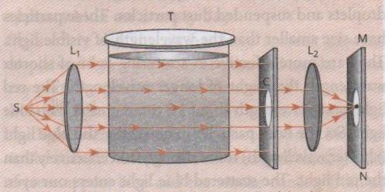

Source : Class X reference book.

3.1 In the above experiment, when the beam of light emerging from the rectangular glass tank having water allowed to pass through a narrow circular hole made in a cardboard. Why a sharp image of the circular hole is obtained on a screen when a second convex lens is placed between the cardboard and screen?

FRAMEWORK | CHARACTERISTICS
Competency | Explain phenomena scientifically
Knowledge System | Content knowledge
Context | Global
Cognitive Demand | low
Item format | Simple question
Proficiency Level | 3

3.2. When the student dissolves about 200g of sodium thiosulphate in 2 L of water in the tank and mix into it 1 to 2 ml of concentrated Sulphuric acid .Initially what will be the colour of light coming out from three sides of the tank?

FRAMEWORK | CHARACTERISTICS
Competency | Explain phenomena scientifically
Knowledge System | Content knowledge
Context | Global
Cognitive Demand | Medium
Item format | Open constructed response items
Proficiency Level | 3

3.3. After some time, the colour of the transmitted light coming from the side of the glass tank facing the circular hole at first the student find orange red colour and then crimson red. Which one of the following reasons is the best explanation for the occurring of colour change?

- Sulphuric acid present in the solution.
- Sodium thiosulphate present in the colloidal solution.
- The size of the Sulphur particles formed during reaction.
- The larger Sulphur particle which forms gradually by cluster of Sulphur particles.

FRAMEWORK | CHARACTERISTICS
Competency | Explain phenomena scientifically
Knowledge System | Content knowledge
Context | Global
Cognitive Demand | Medium
Item format | Short response items
Proficiency Level | 3

Answers
EYE DONATION
1.1
Full Credit:
B Eye donation must be within 4- 6 hours after death.
No credit: for other option or missing answer
1.2
Full credit:
- No
- Yes
- No
No credit: for other option or missing answer
1.3
Full credit:
A) Retina of the eye
No credit: Missing or other response.

1.4
Full credit:
.Eye donation is a noble act. Your cornea can restore the sight of two persons who have lost his or her eye sight. You can live through their eye.

No credit: No response or contrary answer

DEFECT OF VISION
2.1
Full credit: He was having an eye defect called myopia.
No credit: No response or other option
2.2
Full credit:
- Strongly agree
- Strongly agree
- Strongly disagree

No credit: no response or other answer
2.3
Full credit:
- Yes
- No
- No
No credit: No response or contrary answers.
Scattering of Light
3.1. Convex lens is a converging lens, so it converges all the rays that falls on it at one point.
No credit: No response or contrary answers.
3.2. Initially it is blue in colour. Sulphur particles are very small and hence more effective in scattering light of shorter wavelength, like blue colour.
No credit: No response or contrary answers.
3.3. As the reaction proceeds, more and more Sulphur particle are formed which joined to form bigger sized particle. These larger particle scatters orange light more. So, the colour of transmitted light are coming out from all the sides of tank is crimson red.
Prepared by
Mrs. J. N. KUJUR TGT SCIENCE
K. V HINOO 2 nd SHIFT, RANCHI REGION

TEST ITEM 11
Understanding BRAILE SCRIPT
Domain:  Scientific Literacy | Theme:  LIGHT  (Understanding BRAILE SCRIPT) | Class(es): VIII-X  Expected time: 15 min  Total Credit: 10
Description of Item: | Learning Outcome: (As per NCERT)  - analyses and interprets TEXT to derive conclusions  - justifies explanations of the scientific facts  - thinks critically to consider and evaluate alternative explanation.
  Text
  Image
  Table
  Graph
  Map
  Poem

Braille code, employing six embossed dots evenly arranged in rectangular letter spaces or cells, constitutes the dominant touch reading or typing system for the blind. Limited to 63 possible dot combinations per cell, there are a number of application examples, such as mathematics and sciences, and assistive technologies, such as braille displays, in which the 6-dot cell braille is extended to 8-dot. This work proposes a language-independent methodology for the systematic development of an 8-dot braille code. Moreover, a set of design principles is introduced that focuses on: achieving an abbreviated representation of the supported symbols, retaining connectivity with the 6-dot representation, preserving similarity on the transition rules applied in other languages, removing ambiguities, and considering future extensions. The proposed methodology was successfully applied in the development of an 8-dot literary Greek braille code that covers both the modern and the ancient Greek orthography, including diphthongs, digits, and punctuation marks.
[Courtesy: https://link.springer.com/chapter/10.1007/978-3-642-39194-1_39]

Q 1.1: Name the Person who has discovered Braille system?

FRAMEWORK | CHARACTERISTICS
Competency | Demonstrating knowledge and understanding
Knowledge-system | Physical Systems
Context | Global
Cognitive demand | Medium
Item format | Short Response
Proficiency Level | 3

Q 1.2: 8-dot Braille is a Greek Orthography it includes ?

- Maths and Science applications.
- includes diphthongs, digits, and punctuation marks.
- Includes digits and punctuation
- Includes symbols.
FRAMEWORK | CHARACTERISTICS
Competency | Evaluating data and scientific enquiry
Knowledge-system | Physical Systems
Context | Global
Cognitive demand | Medium
Item format | MCQ
Proficiency Level | 3

CREDIT PATTERN:
  - FULLCREDIT:02
  - PARTIALCREDIT:01
  - NOCREDIT:00

Q.1.3: Write answer in Yes/No as per given passage:
- An extension of 8-dot braille work proposes a language-independent methodology for the systematic development of code.
- The proposed methodology was successfully applied in the development of an 8-dot literary Indian braille code.

CREDIT PATTERN:
  - FULLCREDIT:02
  - PARTIALCREDIT:01
  - NOCREDIT:00

FRAMEWORK | CHARACTERISTICS
Competency | Evaluating data and scientific enquiry
Knowledge-system | Physical Systems
Context | Global
Cognitive demand | Medium
Item format | Complex MCQ
Proficiency Level | 3

Q 1.4: How 8-dot Braille system used ? Explain.

CREDIT PATTERN:
  - FULLCREDIT:02
  - PARTIALCREDIT:01
  - NOCREDIT:00

FRAMEWORK | CHARACTERISTICS
Competency | Explaining phenomena scientifically
Knowledge-system | Physical Systems
Context | Global
Cognitive demand | Medium
Item format | Closed Constructed
Proficiency Level | 4

Description of Answer Key and Credits:
Q1.1 Full Credit:(1)Louis Braille has discovered.
Q1.2 Full Credit:(ii) includes diphthongs, digits, and punctuation marks.
Q1.3 Full Credit:(ii) Yes . (iii) No
Partial credit -1
Q1.4 Full Credit:The proposed methodology was successfully applied in the development of an 8-dot literary Greek braille code that covers both the modern and the ancient Greek orthography, including diphthongs, digits, and punctuation marks.

Name of the Teacher/Item Writer: Vineeta Parmar
Designation: TGT (BIOLOGY)
Email: vineetaprmr@gmail.com
Phone No.: 7633817152
Name of the Vidyalaya: KV PATRATU
KVS Region: RANCHI

TEST ITEM -12
Understanding Kaleidoscope
Domain:  Scientific Literacy | Theme:  LIGHT  (Working of Kaleidoscope) | Class(es): VIII-X  Expected time: 25 min  Total Credit: 10
Description of Item: | Learning Outcome: (As per NCERT)  - Analyses and interprets TEXT to derive conclusions  - Justifies explanations of the scientific facts  - Thinks critically to consider and evaluate alternative explanation.
  Text
  Image
  Table
  Graph
  Map
  Poem

Kaleidoscope, optical device consisting of mirrors that reflect images of bits of coloured glass in a symmetrical geometric design through a viewer. A simple kaleidoscope consists of two thin, wedge-shaped mirror strips touching along a common edge or of a single sheet of bright aluminum bent to an angle of 60° or 45°. The mirrors are enclosed in a tube with a viewing eyehole at one end. At the other end is a thin, flat box that can be rotated; it is made from two glass disks, the outer one ground to act as a diffusing screen. In this box are pieces of coloured glass, tinsel, or beads. When the box is turned or tapped, the objects inside tumble into an arbitrary grouping, and when the diffusing screen is illuminated, the six-fold or eightfold multiplication creates a striking symmetrical pattern. The number of combinations and patterns is effectively without limit. The incline of the two mirrors inside a kaleidoscope determines the number of times the pattern created by the reflection of an object is repeated.
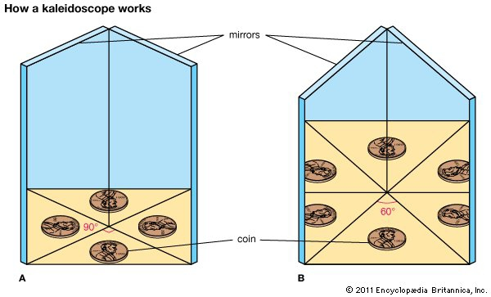
Encyclopedia Britannica, Inc.

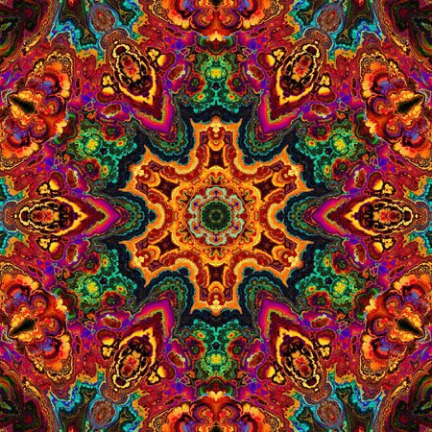

Q 1.1: What is Science behind Kaleidoscope?

FRAMEWORK | CHARACTERISTICS
Competency | Demonstrating knowledge and understanding
Knowledge-system | Physical Systems
Context | Global
Cognitive demand | Medium
Item format | Short Response
Proficiency Level | 3

Q 1.2: Basic principle of Kaleidoscope is ?

- Laws of Reflection.
- Laws of Scattering.
- Laws of dispersion
- Laws of reflection and White light is the combination of VIBGYOR.
FRAMEWORK | CHARACTERISTICS
Competency | Evaluating data and scientific enquiry
Knowledge-system | Physical Systems
Context | Global
Cognitive demand | Medium
Item format | MCQ
Proficiency Level | 3

Q.1.3: Write answer in Yes/No as per given passage:
(i)If the mirrors are positioned at a right angle, four images of the object can be seen.
(ii) If the mirrors' surfaces are positioned at 60°, nine images of the object appear.
FRAMEWORK | CHARACTERISTICS
Competency | Evaluating data and scientific enquiry
Knowledge-system | Physical Systems
Context | Global
Cognitive demand | Medium
Item format | Complex MCQ
Proficiency Level | 3

Q 1.4: How does multiple reflection occur in Kaleidoscope ? Explain.
FRAMEWORK | CHARACTERISTICS
Competency | Explaining phenomena scientifically
Knowledge-system | Physical Systems
Context | Global
Cognitive demand | Medium
Item format | Closed Constructed
Proficiency Level | 4

Description of Answer Key and Credits:
Q1.1 Full Credit: It works when two or more reflecting surfaces tilted to each other in an angle, so that one or more objects on one end seen as regular symmetrical pattern.
Q1.2 Full Credit:(Iv) Laws of reflection and White light is the combination
of VIBGYOR.
Q1.3 Full Credit:(i) Yes . (ii) No
Partial credit -1
Q1.4 Full Credit: If an object is placed between two mirrors inclined at right angles, an image is formed in each mirror. ... kaleidoscope the incline of the two mirrors inside a kaleidoscope determines the number of times the pattern created by the reflection of an object is repeated.

Name of the Teacher/Item Writer: Vineeta Parmar
Designation: TGT (BIOLOGY)
Email: vineetaprmr@gmail.com
Phone No.: 7633817152
Name of the Vidyalaya: KV PATRATU
KVS Region: RANCHI

